**LAB MST Worksheet 3/14/22**

**Student Name**: Sahil Kaundal **UID:** 21BCS8197

**Branch:** BE_CSE  **Section/Group:** 807_B

**Semester:** 4th **Date of Performance:** 14/03/2022

**Subject Name:** Python Programming Lab **Subject Code:** 20CSP-259

**1. Aim/Overview of the practical:**

Write a Python program to convert a tuple of string values to a tuple of integer values.

**2. Task to be done:**

Python program to convert a tuple of string values to a tuple of integer values.

**3. Apparatus/Simulator used (For applied/experimental sciences/materials based labs):**

Online GDB, IDLE.

**4. Algorithm/Flowchart (For programming based labs):**

**Python Strings:**

A string is a sequence of characters.

Strings in python are surrounded by either single quotation marks, or double quotation marks.

**Python Integers:**

Number data types store numeric values.

They are immutable data types, which mean that changing the value of a number data type results in a newly allocated object.

**Flowchart:**

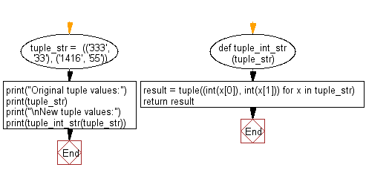

**5. Description/ Code:**

**#** Python program to convert a tuple of string values to a tuple of integer values

def tuple_int_str(tuple_str):

result = tuple((int(x[0]), int(x[1])) for x in tuple_str)

return result

tuple_str = (('546', '323'), ('143', '99'))

print("Tuple Values in String form")

print(tuple_str)

print("\nTuple Converted to Integer:")

print(tuple_int_str(tuple_str))

**6. Result/Output/Writing Summary:**

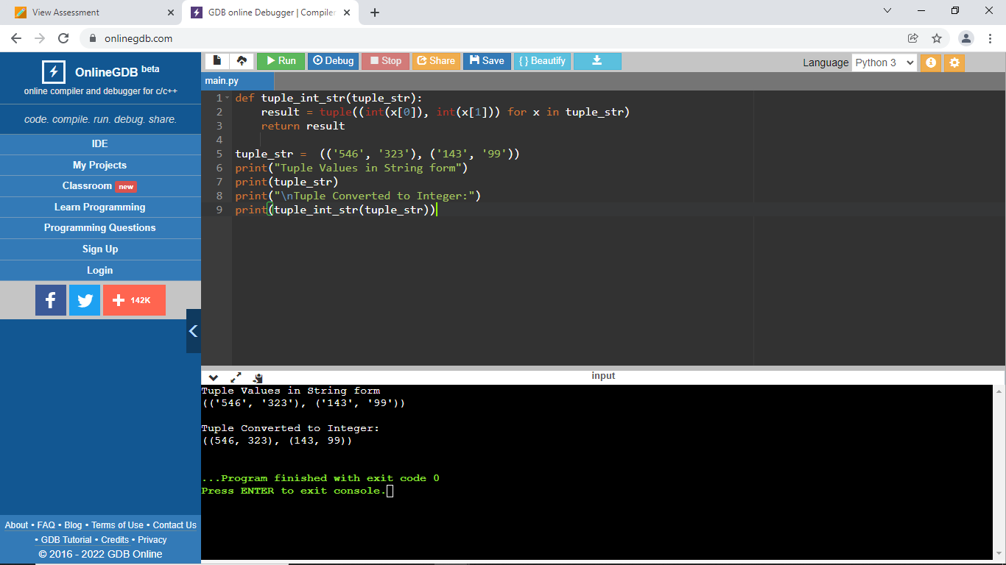

**Learning outcomes (What I have learnt):**

1. Python program to convert a tuple of string values to a tuple of integer values.
2. Use of tuples.
3. Use of Strings.
4. Use of Integers.

**Evaluation Grid (To be created as per the SOP and Assessment guidelines by the faculty):**

|  |  |  |  |
| --- | --- | --- | --- |
| Sr. No. | Parameters | Marks Obtained | Maximum Marks |
| 1. |  |  |  |
| 2. |  |  |  |
| 3. |  |  |  |
|  |  |  |  |